**Sarah Archino**

**Arensberg, Walter** Word Count: 519

Walter Arensberg (April 4, 1878-January 29, 1954) and his wife, Louise Stevens Arensberg (1879-1953), were influential patrons of the avant-garde, building a collection that included modernist art, early American Shaker furniture, and non-Western objects, primarily of African and pre-Columbian origin. They collected modern art by American and European artists, with a special concentration in work by Marcel Duchamp (who also served as their art advisor) and Constantin Brancusi. Their New York apartment, at 33 West 67th Street, hosted a frequent salon of artists, writers, and intellectuals from 1915-1921.These gatherings were a focal point for the activities and antics of New York Dada. Among Arensberg’s many friendships with artists and writers, his long association with Marcel Duchamp was perhaps most influential. When Duchamp arrived in New York in 1915, Walter Pach met him at the pier and brought him directly to the Arensberg’s apartment, where Duchamp lived during the summer of 1915. Later, Arensberg paid the rent for Duchamp’s studio, located in the same building. The Arensberg Collection would amass nearly forty works by Duchamp, including *The Bride Stripped Bare by her Bachelors, Even (The Large Glass)* (1921). When Arensberg was unable to purchase the artist’s infamous *Nude Descending a Staircase No. 2* (1912), he commissioned a duplicate and eventually acquired the original, as well.

Arensberg began collecting modern art at the 1913 International Exhibition of Modern Art (known as the Armory Show) where he purchased prints by Paul Cézanne and Paul Gauguin, along with a small oil painting by Jacques Villon, *Sketch for ‘Puteaux: Smoke and Trees in Bloom,’ No. 2*. (1912). Arensberg was a founding member of the Society of Independent Artists, although he resigned in solidarity with Marcel Duchamp in the wake of the controversy over Duchamp’s *Fountain* (1917). In addition to collecting visual art, Arensberg was a writer and literary scholar, writing primarily on Dante Alegheri and Francis Bacon, and contributed poetry to a number of literary journals, including *Others*. A graduate of Harvard University with a degree in English, Arensberg published two books of poetry, *Poems* (1914) and *Idols* (1916). In 1937, the Arensbergs founded the Francis Bacon Foundation, now at the Huntington Library in San Marino, CA, to promote ‘research in history, philosophy, science, literature, and art, with special reference to the life and works of Francis Bacon.’ Upon the death of both Louise and Walter Arensberg in 1953, their art collection, collection of ephemera and personal papers were bequeathed to the Philadelphia Museum of Art, where they form the Walter and Louise Arensberg Collection.

**References and Further Reading:**

Kuh, K. (1971) ‘Walter Arensberg and Marcel Duchamp’, *The Open Eye: In Pursuit of Art*, New York: HarperCollins.

Martin, M (ed) (1954) *The Walter and Louise Arensberg Collection*, Philadelphia: Philadelphia Museum of Art.

Naumann, F. (1980) ‘Walter Conrad Arensberg: Poet, Patron, and Participant in the New York Avant-garde’, *Bulletin of the Philadelphia Museum of Art* xxvi (328): 2-32.

Naumann, F. (1994) New York Dada, 1915–23, New York: Harry N. Abrams.

Nesbit M. and N. Sawelson-Gorse (1996) ‘The Concept of Nothing: New Notes by Marcel Duchamp and Walter Arensberg’, *The Duchamp Effect: Essays, Interviews, Round Table*, Cambridge: The MIT Press.

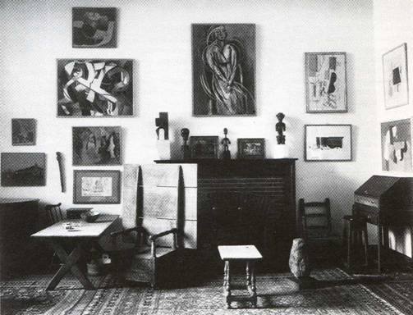

**Image included: view of the Arensberg’s apartment. Photograph taken by Charles Sheeler, 1918. Philadelphia Museum of Art.**

**http://www.philamuseum.org/collections/permanent/193665.html?mulR=1585**